RETAIL SALES DATA PROCESSING AND BUSINESS INSIGHTS GENERATION

MINI PROJECT REPORT

Submitted By
Name: Buddhadeb Giri
Roll Number: 10300222062
Department of Information Technology
College Name: Haldia Institute of Technology
Academic Session: 2025–26

ABSTRACT
Retail organizations generate large volumes of transaction data through multiple sales channels. However, raw transactional datasets often contain inconsistencies such as duplicate records, missing values, inconsistent category naming conventions, invalid quantities, and varying date formats.
The objective of this project is to design and implement an end-to-end retail sales analytics solution using Python and Power BI. The project involves data ingestion, cleaning, transformation, data quality validation, personally identifiable information (PII) masking, KPI generation, and dashboard development.
The final solution provides meaningful business insights including revenue analysis, product performance analysis, category performance, payment method analysis, and regional sales insights through interactive Power BI dashboards.
Keywords: Data Engineering, Data Cleaning, Business Intelligence, Power BI, Retail Analytics, KPI Reporting.

TABLE OF CONTENTS
- Introduction
- Problem Statement
- Objectives
- Dataset Description
- System Requirements
- Project Architecture
- Workflow Diagram
- Methodology
- Data Cleaning Strategy
- Data Transformation Logic
- PII Masking Implementation
- KPI Calculation
- Power BI Dashboard Design
- Results and Insights
- Advantages
- Limitations
- Future Scope
- Conclusion
- References

CHAPTER 1: INTRODUCTION
Data-driven decision-making has become a critical requirement for modern retail organizations. Retail companies collect transactional data from multiple locations, products, customers, and payment systems. Analyzing this data enables organizations to identify revenue trends, customer behavior, product performance, and regional sales patterns.
This project demonstrates the implementation of a complete retail analytics pipeline that converts raw transactional data into meaningful business insights using Python and Power BI.

CHAPTER 2: PROBLEM STATEMENT
ABC Retail Solutions collects retail transaction data from multiple source systems. The datasets contain several quality issues such as:
• Duplicate transactions
• Missing values
• Inconsistent category naming
• Invalid quantities and pricing information
• Different date formats
• Sensitive customer information
These issues make reporting and business analysis difficult. Therefore, a standardized data engineering pipeline is required to transform raw data into a reliable business reporting dataset.

CHAPTER 3: OBJECTIVES
The objectives of this project are:
- Ingest retail transaction data from multiple sources.
- Validate and clean data.
- Handle missing and inconsistent values.
- Standardize categories and product information.
- Protect sensitive customer information using masking techniques.
- Generate business KPIs.
- Develop interactive Power BI dashboards.
- Produce actionable business insights.

CHAPTER 4: DATASET DESCRIPTION

Product Details Dataset
The product_details dataset contains standardized product information including:
• Product ID
• Product Name
• Category
• Standard Product Price
This dataset acts as a reference table during validation and enrichment.

Number of Records
10

Retail Dataset 1
Contains retail transaction information collected from one transactional source system.

Number of Records
4243

Retail Dataset 2
Contains retail transaction information collected from a second source system.

Number of Records
4251

CHAPTER 5: SYSTEM REQUIREMENTS

Hardware Requirements
• Intel Core i5 Processor or Above
• 8 GB RAM
• 20 GB Free Disk Space

Software Requirements
• Python 3.x
• Visual Studio Code
• Pandas Library
• NumPy Library
• OpenPyXL
• Power BI Desktop
• Microsoft Excel

CHAPTER 6: PROJECT ARCHITECTURE
The architecture consists of Data Sources, Data Ingestion Layer, Data Cleaning Layer, PII Masking Layer, KPI Generation Layer, and Power BI Dashboard Layer.

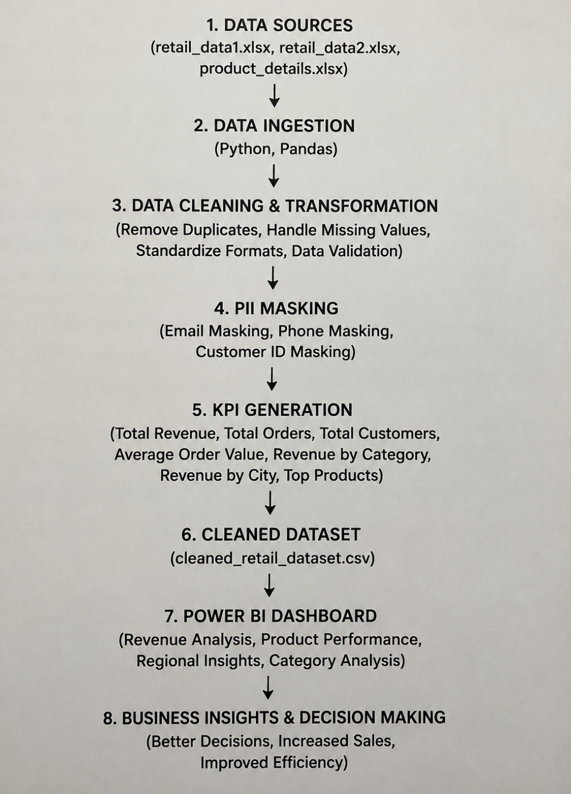

CHAPTER 7: WORKFLOW DIAGRAM
Workflow:
Source Files → Data Ingestion → Data Validation → Data Cleaning → PII Masking → KPI Generation → Dashboard Reporting
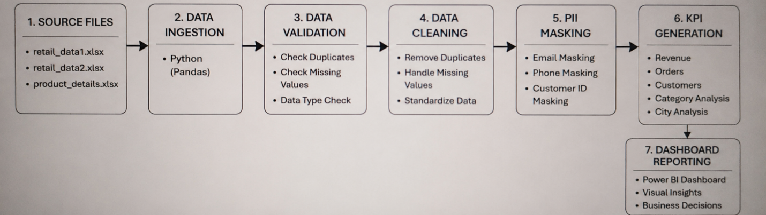

CHAPTER 8: METHODOLOGY
Step 1: Load source datasets.
Step 2: Merge retail datasets.
Step 3: Perform data validation.
Step 4: Handle missing values.
Step 5: Remove duplicate records.
Step 6: Standardize category values.
Step 7: Convert date formats.
Step 8: Mask customer information.
Step 9: Generate revenue metrics.
Step 10: Export curated dataset.
Step 11: Build Power BI dashboard.

CHAPTER 9: DATA CLEANING STRATEGY
The following cleaning operations were performed:
• Duplicate transaction removal
• Missing value handling
• Date standardization
• Category normalization
• Invalid quantity removal
• Invalid price validation
Category mappings used:
ELEC → Electronics
FURN → Furniture
These transformations improved data consistency and reporting accuracy.

CHAPTER 10: DATA TRANSFORMATION LOGIC
Transformation pipeline:
Raw Dataset
↓
Merge Retail Sources
↓
Data Validation
↓
Data Cleaning
↓
PII Masking
↓
Revenue Calculation
↓
Curated Dataset
↓
Power BI Dashboard

CHAPTER 11: PII MASKING IMPLEMENTATION
Sensitive customer information was protected using masking techniques.
Email Example:
Original:
johnsmith@example.com
Masked:
jo****@example.com
Phone Example:
Original:
9876543210
Masked:
XXXXXX3210
This ensures customer privacy while retaining analytical usefulness.

CHAPTER 12: KPI CALCULATION
Revenue Formula:
Revenue = Price × Quantity × (1 − Discount)
KPIs generated:
• Total Revenue
• Total Orders
• Total Customers
• Average Order Value
• Revenue by Category
• Revenue by City
• Revenue by Product
• Revenue by Payment Method

CHAPTER 13: POWER BI DASHBOARD DESIGN
Dashboard Pages:

Executive Summary
• Total Revenue
• Total Orders
• Total Customers
• Average Order Value

Revenue Analysis
• Revenue Trend
• Revenue by Payment Method
• Revenue by Category

Product Performance
• Top Products
• Product Revenue

Regional Insights
• Revenue by City
• Geographic Sales Distribution

Category Analysis
• Category Revenue
• Category Contribution
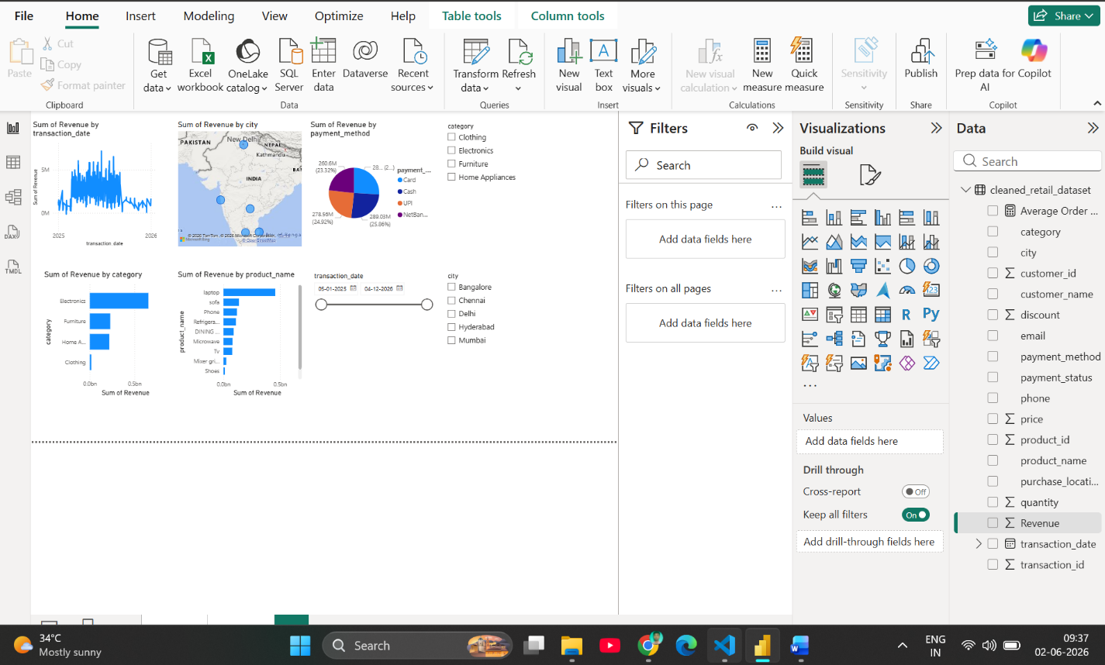

CHAPTER 14: RESULTS AND INSIGHTS
The dashboard generated several business insights:
• Electronics category generated the highest revenue.
• Revenue distribution varied significantly across cities.
• Certain products contributed disproportionately to total revenue.
• Digital payment methods showed strong adoption.
• Revenue trends revealed seasonal fluctuations.

CHAPTER 15: ADVANTAGES
• Improved data quality
• Faster business reporting
• Interactive analytics
• Secure customer data handling
• Better decision support

CHAPTER 16: LIMITATIONS
• Limited dataset size
• Historical analysis only
• No real-time streaming data
• No predictive analytics component

CHAPTER 17: FUTURE SCOPE
• Real-time data processing
• Cloud deployment using Azure
• Sales forecasting using Machine Learning
• Customer segmentation analysis
• Automated ETL orchestration

CHAPTER 18: CONCLUSION
This project successfully implemented a complete retail sales analytics solution using Python and Power BI. Data quality issues were resolved through cleaning and transformation processes, customer privacy was preserved using masking techniques, and meaningful KPIs were generated through business intelligence reporting.
The resulting dashboard enables effective analysis of revenue trends, product performance, category contributions, and regional sales behavior, supporting data-driven business decisions.

REFERENCES
- Microsoft Power BI Documentation.
- Python Official Documentation.
- Pandas Documentation.
- NumPy Documentation.
- Data Warehousing and Business Intelligence Concepts.

